XHTML & Website Design
Project Group Process Workbook
2013

Assignment Assessment Overview

Each Group should complete the following in relation to the Group work process and submit as part of your project.

Group Report and Logbook | 20%
Progress Report – There should be at least 2 progress-report entries posted by each Group | 3%
Template 1 – Roles & Responsibilities | See below
Template 2 – Understanding the Problem | 1%
Template 3 – Exploring Ideas | 2%
Template 4 – Group Action Plan | 2%
Template 5 – Individual Action Plan | 3%
Template 6 – Individual Reflection | 3%
Template 7 – Bibliography | 1%
Template 8 – Peer Review | 5%

Template 1 Roles & Responsibilities

Roles & Responsabilities

In order for the group to work effectively it is necessary for members to take responsibility for specific tasks. Assign a group member to each of the roles. If a group member is not performing their role this must be managed within the group. If this cannot be addressed within the group please contact one of your Project lecturers as soon as possible.

Role | Responsibility | Team Member
Chairperson | Ensures each member remains on task and ensures that all members have a voice | Conor
Time Keeper | Ensures that all tasks are completed on schedule and that meeting time is used appropriately | Gavin
Record Keeper | Ensures that all ideas are documented and templates are completed | Gavin

Template 2 Understanding the Problem


INTERPRET THE PROBLEM

Using the headings below, discuss the details of the assignment amongst group members and fill out the template.

- Define the problem. What are you being asked to do? Have you finalised on your subject area for your website?
- We are being asked to design a website for an assigned business. The assigned business we got is to design a website for getting movies online. We are asked to do four pages of XHTML, use CSS, a navigation system and some javascript.

- List the different XHTML concepts & Web design considerations that will need to be understood in order to complete this assignment.
The document needs to be well formed

- What approach will be taken to implement the website e.g. CSS/tables? Explain your reasons for decisions taken.
Well, we're using CSS to style are web page and make it look good to the user. We're using java script to allow the user to reserve a copy of a movie which fulfills the purpose of the page.

- What has been your Group’s strategy for validating your code? How have you approached this?
We try to validate our website as much as possible. Whenever we do a new bit of coding and it works we validate to see if we've done it properly and if we haven't to find out where the mistakes are and correct them.

Understanding the Problem

Project requirements

List the requirements that you have for your website

- What is the overall goal of your website?
To provide an easy way to navigate around the site which will benefit them in looking for the specific movie, game or CD that they want and then be able to reserve it online

- What are the functional requirements for your site? What will the site do?
We want our site to be able to let customers browse movies, Games or Cds easily and to be able to reserve them online by entering in some details. We also want to inform our customers of the latest releases and the deals available. There has to be a 10mb restriction

e

- What are the non-functional requirements of your site? Do you have a preference for the look and feel of the site?
On every page we will have the name of the company which is “Mcguinns Movies” as the main heading. There will be a dropdown menu on each page and categories for the DVDs games or CD’s. We’ll have a map which shows the location of the store and a login/register page .

- What other requirements do you want to achieve in your site?
We want customers to be able to register and login and this will allow them to reserve or buy DVD’s, Music or games. Customers will be able to contact us with any queries they may have through email or phone

Template 3 Exploring Ideas

Exploring ideas – What will the user interface look like?

Discuss possible designs for your website. Once the group decides on a design use Microsoft Word or a Balsamique Mockup to demonstrate the chosen design and layout of website.

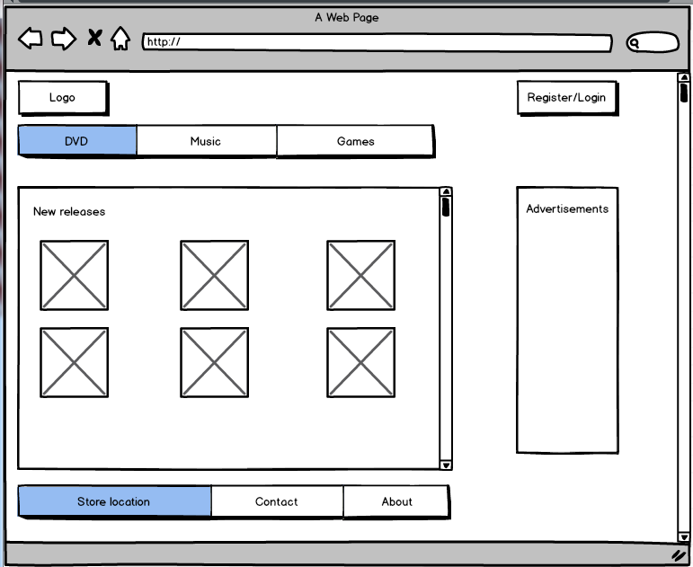

Exploring Ideas

Exploring ideas – What will the user interface look like?
Include Wireframes here
Home page
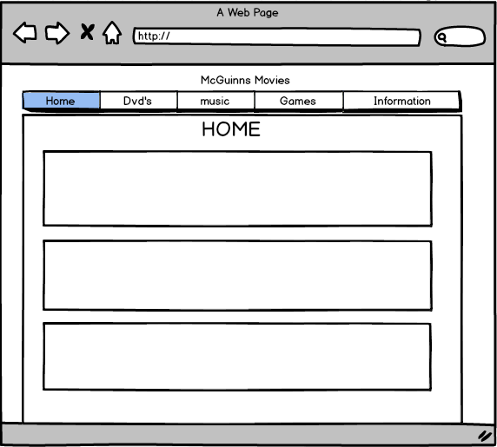
DVD/Games/Music Page
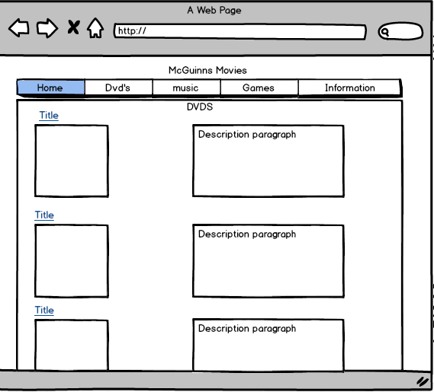
Each movie/Game/CD page
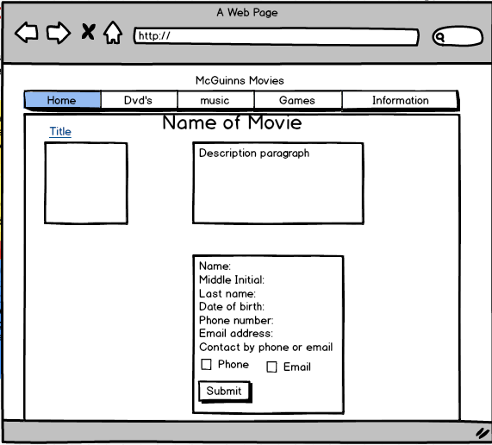

Information page
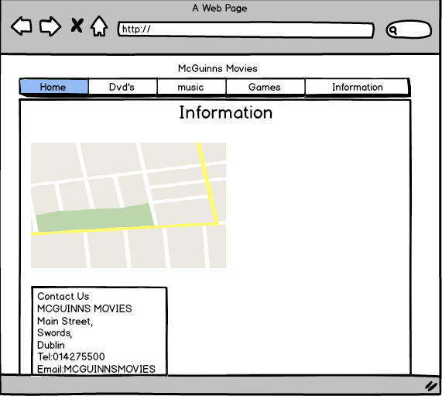

Template 4 Group Action Plan

Group Action Plan
List the tasks your group needs to complete
Assign tasks to each group member and agree on appropriate timelines

Action Plan:
No. | Action | Responsibility | Completed
1  Balsamique Mockup | Design layout of our page | Gavin  Conor | 24/10/13
2  Requirements | Find out the requirements | Gavin  Conor | 14/11/13
3Wireframe | Draw it | Gavin | 21/11/13
4  Start coding |  | Gavin  Conor | 28/11/13
5  Finish project | Tidy it up and validate | Gavin | 08/12/13
6  Finish Workbook |  | Conor | 08/12/13
7

8

9

10

Template 5 Individual Action Plan
Group member 1 should fill in this page


Individual Action Plan
Based on the task(s) assigned to you – record and synopsise your findings under the headings below.
Student Details: Student Name____Conor Grant___________________ Student Number______13522167___________

- What task(s) have you been assigned?
I'm the chairperson. I will be presenting our project, do the workbook, the information page on our project and helped with the index

- What information did you find out from your research?
Our website has to clear and easy for the user to read. We need to promote the movies we'll be selling. Give information about us like how to contact us and where we are. We have to be able to reserve/sell movies.

- Explain how this information may be useful in the development of the website.
Our website has to be clear and easy to understand for the user because if it's not they will just use another website. We have to give information about us because if any problems arise they'll be able to contact us.

- What are you going to feedback to the group?
We want our website to be easy to use.

- Reference the information you have found.
http://www.xtra-vision.ie/
http://www.w3schools.com/googleAPI/google_maps_basic.asp

Individual Action Plan
Group Member 2 should fill in this page

Individual Action Plan
Based on the task(s) assigned to you – record and synopsise your findings under the headings below.
Student Details: Student Name_Gavin Johnston_______ Student Number_X13477082_______

- What task(s) have you been assigned?
I am the record and Time keeper I will be finding information on the products linking each page together and designing some webpages

- What information did you find out from your research?
That we need to include the most popular and newest releases give a clear way to finding what you’re looking for and to reserve it.

- Explain how this information may be useful in the development of the website.
Our page must be simple to use in order to help the user find what they are looking if not they will try to find an easier alternative route to do what they can which would result in using other services over ours. Users will constantly be searching for new and popular releases so it is important to keep them accessible within the website along with others.

- What are you going to feedback to the group?
That it is important the webpage must include new and popular releases as well as others That the way to navigate around the web page is as easy as possible by including menus clickable images as well as titles.

- Reference the information you have found.
www.xtra-vision.ie
www.hmv.ie
www.w3schools.com

Individual Action Plan
Group Member 3 should fill in this page

Individual Action Plan
Based on the task(s) assigned to you – record and synopsise your findings under the headings below.
Student Details: Student Name_______________________ Student Number_________________

- What task(s) have you been assigned?

- What information did you find out from your research?

- Explain how this information may be useful in the development of the website.

- What are you going to feedback to the group?

- Reference the information you have found.

Template 6 Reflection
Group Member 1 should fill in this page

REFLECTION
It is important for the group to reflect on how they arrived at the solution and the solution itself and to identify what could be improved on next time. (Students should complete about 500 words reflection)
Student Details: Student Name________Conor Grant_______________ Student Number________13522167_________
- Overall what has the experience been like working as part of a project team?
I enjoyed working as part of a team. You have to delegate tasks that have to be done which means you don't have to everything by yourself. You feel valued and are therefore more motivated to do well. You get to share power and from that you get the best information and ideas that are available, resulting in good quality. I built up trust with my partner.

- What have been the most positive parts?
The most positive parts were at the end when it all come together. We were a bit worried we'd run out of time but then when we got everything done we were delighted with ourselves

- What could be improved on next time?
At the start of the project we were very relaxed about it and didn't put much efforts into it but as the weeks flew by we found ourselves under a bit of pressure to complete the project, so what we'd improve next time is delegating our time better and put more work into it at the start.

Template 6 Reflection
Group Member 2 should fill in this page

REFLECTION
It is important for the group to reflect on how they arrived at the solution and the solution itself and to identify what could be improved on next time. (Students should complete about 500 words reflection)
Student Details: Student Name_Gavin Johnston_______ Student Number_X13477082_______

- Overall what has the experience been like working as part of a project team?
My experience with working within a group was a very positive and enjoyable experience it was both challenging and enjoyable to complete each task and to meet the deadline while doing so. I would have found working individually on this project to be a very boring and demanding task otherwise.

- What have been the most positive parts?
When working in a group it is a good way to work as the whole work load is then halved giving you less to do this also is a great way to meet new people to learn from each other, learn about each others interests and to have another person to give you feedback on the ideas that you bring to the table.

- What could be improved on next time?
- To start the project early so you have enough time to edit and adjust you project if needs be instead of leaving most things to the last weekend and working under pressure to complete it on time (Which unfortunately was the case this time around.)
- To set out certain goals week by week and to fulfil them so we are not running behind on time.
- To work on brainstorming and planning your project out before going straight into it.

Template 6 Reflection
Group Member 3 should fill in this page

REFLECTION
It is important for the group to reflect on how they arrived at the solution and the solution itself and to identify what could be improved on next time. (Students should complete about 500 words reflection)
Student Details: Student Name_______________________ Student Number_________________

- Overall what has the experience been like working as part of a project team?

- What have been the most positive parts?

- What could be improved on next time?

Template 7 Bibliography

Referencing
You must reference any books, articles, or web pages which you used to create your web pages. This might include content for your site or resources on how to use a piece of JavaScript code. You must use the Harvard Referencing Style. There are resources on moodle to help you with this style.

Template 8 Peer Review
PEER REVIEW
When all group members contribute equally it makes sense for everyone to get the same result. However, if group members do not contribute evenly it is only fair that each group member receives the mark that truly reflects their contribution.

Each group member can earn a maximum of 10 marks for their contribution. Group members who made little or no contribution will receive fewer marks. The group must collectively rate each member’s contribution in the grid below by writing the member’s name in the box the group feels is most appropriate.
Main Contributor(s)    10 marks | Secondary Contributor(s)    7 marks | Minimal Contribution    3 marks | No Contribution    0 marks in Assignment
Gavin | Conor

I ______Conor Grant________________________ agree with the marks that have been awarded for my contribution to the assignment.
I ______Gavin Johnston__________ agree with the marks that have been awarded for my contribution to the assignment.
I ______________________________ agree with the marks that have been awarded for my contribution to the assignment.

